HALSE AND DISTRICT COMMUNITY BENEFIT SOCIETY
SEVENTH SHARE OFFER
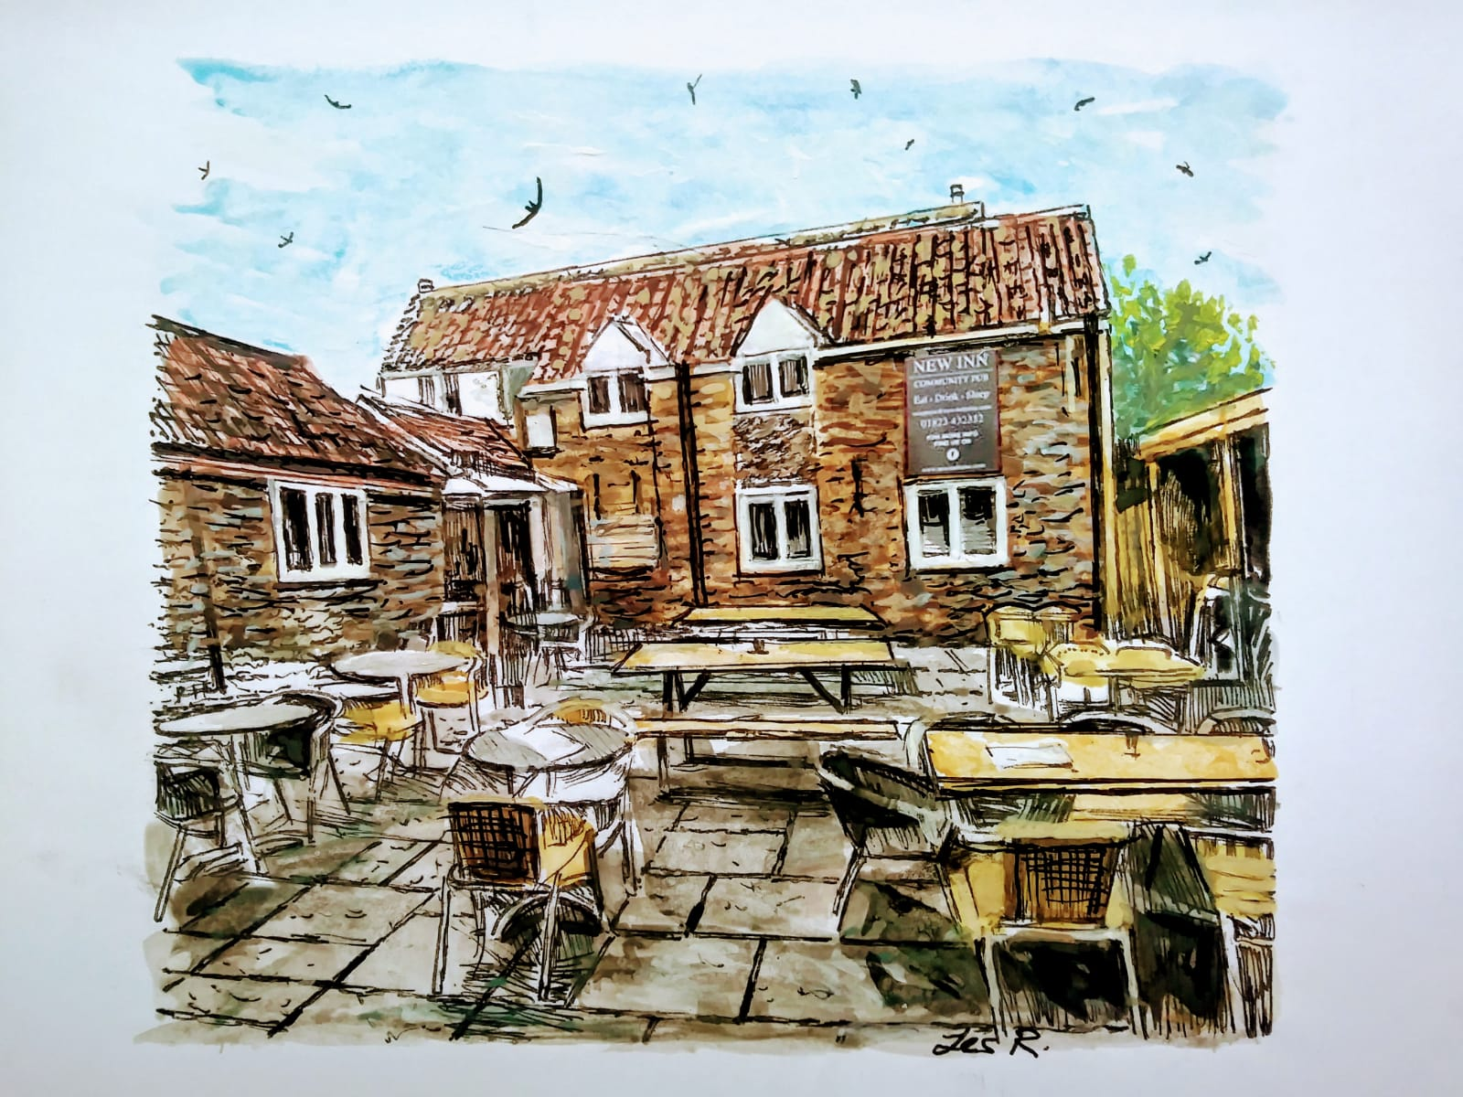

Dear [resident name],

Introduction
This share offer invitation is from the Management Committee of the Halse and District Community Benefit Society, which was formed with the vision of refurbishing the New Inn at Halse for the benefit of the community and to secure its future as a thriving community hub.
Share offer summary
Minimum target to be raised: £10,000
Maximum target to be raised: £100,000
Price per share: £1
Minimum share holding: £100
Maximum share holding: £50,000
Offer opens on ___1st Jan 2026 and will stay open until 31st Dec 2026.

The story so far
The New Inn at Halse is an 18th century coaching inn, formerly known as The Kings Arms, The Butchers Arms and The Red Lion. It became the New Inn in 1789. The New Inn has been very successful in the past and following an extensive renovation in 2005 was a thriving pub, restaurant and B&B business. Business declined over the last 10 years and the New Inn found itself in danger of closing. It was purchased by the local community in September 2020 and has been refurbished by funds raised in our first share issue and grants. A month after opening in October 2020 the New Inn closed, for all but takeaways, in response to COVID restrictions.
Throughout the COVID restriction refurbishing work was carried out. A business framework was established with the aim that the New Inn would continue to operate and continue to be an asset to the local community. Funding of £382,000 from the first share issue in addition to a £100,000 injection from the Plunkett Foundation put the New Inn on the right trajectory for survival. The appointment a competent Management Committee and Management Team saw the New Inn doubling the projected monthly income before the second Covid lockdown which was imposed in November 2020. During this second lockdown refurbishment continued, new facilities and services on offer were improved and refurbished B&B rooms opened in mid 2021.
Management continually looks to raise additional funding to be able to improve and add to the services being offered. 2022 proved to be a difficult period for the hospitality industry in the UK and the New Inn was no exception, electricity and gas prices increased significantly as did all other material costs associated with the hospitality industry. Unfortunately, 2023 did not see the hoped for easing of the headwinds facing the industry and 2024 was just as bad with National Insurance hit.. 2025 started to show a light at the end of the tunnel with a good set of accounts showing a little profit. Our vision was and remains, to give our customers the best experience possible. We have made every effort to effectively manage our operating costs to remain not only competitive but to present an affordable product for our customers..
The New Inn
For most villages a pub is an important service; it is a meeting place, communication centre and the lynchpin of village life. Much of the appeal of our village rests on its sense of community. An active village pub is a factor which people consider positively when making the decision to relocate to or remain in Halse. The existence of our community pub with the café and B&B rooms has enhanced the community spirit and given Halse and District a stronger sense of place.
The primary objective was to refurbish and operate the New Inn as a community asset which meets the needs of the community, to achieve this the New Inn has to operate as a profitable business. The restaurant provides food and facilities that suit the whole family, young and old but we have to attract customers / visitors from outside the district in order to survive yet our main focus remains engaging the close community.
The café continues to provide a much needed social opportunity for the community and is growing in popularity as a stop off spot for cyclists, ramblers and tourist visiting the area.
We provide five en-suite rooms for B&B and a sixth studio apartment; all are competitively priced and have so far produced a regular income with good customer feedback and reviews.
Current Services
Management continues to consider other services which were highlighted in the initial Community Q&A, to date we have hosted many new activities.
Halse Players Productions; Movie Nights; Food Theme Evenings; Live Music; Monthly Quiz Night.
Fitzhead Lunch Club meet on a monthly basis as do the Wiveliscombe Rotary Club.
The Café has art exhibits and a book exchange and takes part in the 10 parishes exhibition.
A number of awards have already been made to the New Inn including runner up in the Somerset pub of the year, Plunkett award for the best community offering, CAMRA best local pub, Best cycle stop.
Business Plan
The original Business Plan created in 2020 is now out of date and many things have changed since then, particularly:

Thanks to the hard work of the original Management Committee and many volunteers, the required refurbishment work was satisfactorily completed within the budget parameters initially set out.

Our sales volumes for both food and drink have massively exceeded our original projections – very nearly double.

The New Inn has gained an excellent local reputation, including being top ranked locally on Trip Advisor.

Because of the higher volumes seen in all departments, our costs have increased well beyond originally budgeted levels. In addition, industry conditions have worked against us, with hospitality wages running at record levels and material costs at a high level as well. Added to that, inflation is a threat to discretionary spending.

We are therefore in the process of updating our Business Plan with specific emphasis on both profitability and cashflow.

Financial Performance to Date

Since the initial share offer there have been three sets of Accountant prepared unaudited financial statements produced, one for the initial trading period 24/8/2020 to 30/9/2021 and the others for the ensuing 12 month periods up to 30/9/2023. The 2025 accounts are being prepared and will be released in Mar 2026. A brief summary of these follows and our accounts can be examined in full on the New Inn website:

30/9/2021

These show a pre tax loss for the period totalling £120,311. This figure is after charging refurbishment costs of £199,039 during the period which have to be accounted for as a charge against profits in that year. Only ‘additions’ can be added to capital. It should be noted, however, that this expenditure has been necessary for the benefit of the building and will have added to the capital value of the same. On the other hand, during the year there was a non-recurring benefit of £112,771 from Grant Income, some of which will have related to the improvement project and some in the form of Government Covid Support*

On a simple calculation, therefore, the contribution from trading in a year badly affected by Covid was a loss/deficit of some £34,043 before tax.

30/9/2022

This again was a trading period partly affected by Covid and the pre tax loss for the period was £56,003 which includes refurbishment costs of £24,155, implying a loss/deficit from trading of £31,848, a small improvement on the previous year.

30/9/2023

We saw a further improvement in trading performance in the full year with turnover reaching £596,236 and our operating deficit reducing from £50k in 2022 to 6k in 2023. .

30/9/24 & 25

A regular team both in the kitchen and bar have helped make the New Inn a popular venue where all are welcome. This is reflected in our trading.

The Structure
The Halse and District Community Benefit Society Ltd (‘H&D CBS’) registration no 8456 was formed using the model rules developed by the Plunkett Foundation and registered with the Financial Conduct Authority (FCA). In its rules is embedded the principle that if the society has a surplus, this will be made available for distribution to other community or charitable projects.
The primary objective of the society is to run the New Inn for the benefit of the community, and in the longer term, whenever there is any surplus, to use this surplus for the benefit of the wider community of Halse and its surrounding district.
The responsibility of H&D CBS is to oversee the business operations of the New Inn. This is achieved by the Management Committee, equivalent to a Non Executive Board of Directors, who oversee the Management Team who manage the operations of the New Inn.
The First Management Committee was appointed by the Steering Group to serve until the first AGM which was held _in January 2022.
At all subsequent AGM’s 1/3rd of members of the Management Committee stand down and elections take place to appoint a new Management Committee.members
The committee has 12 positions including::

Chairman: Vice Chair: Treasurer:
Secretary: Media: Policies & Welfare:.
Fund-raising + Volunteers: Corporate Partners Legal
Property Improvement and Maintenance: Financial Controller

Each share is worth £1 and there is a minimum holding of £100 and a maximum of £50,000. Anyone who invests the minimum of £100 becomes a Member of the Society and has a vote and therefore a voice in the affairs of the business at General Meetings. The structure operates strictly on a one Member, one vote basis, regardless of how many shares you hold.
In forming the H&D CBS care was taken to ensure there is an Asset Lock on the assets the H&D CBS held, which is essentially the premises.
Shares can be redeemed by a Member subject to certain terms and conditions, however the premises cannot be sold unless it is for the benefit of the community.

The Share Offer

This community share offer invites you to invest in the Halse and District Community Benefit Society Ltd (‘H&D CBS’) so that the New Inn can support its future operations. The New Inn day to day operations are managed by the Management Team. The H&D CBS Management Committee oversee the operations and finances of the New Inn in conjunction with the Management Team.
Shares issued under this 7th Share Issue stand pari passu (equal footing) with all other shares issued under earlier Share Issues.
Each share is worth £1 and there is a minimum holding of £100 and a maximum of £50,000. Anyone who invests the minimum of £100 becomes a Member of the Society and has a vote and therefore a voice in the affairs of the business at General Meetings. The business operates strictly on a one Member, one vote basis, regardless of how many shares you hold. Members must be 18 years old and over, although shares can be held in trust until a person becomes 18 years old.
The share offer will remain open to applications until 31st December 2023.
Any Investment should be regarded as a long-term social investment with possible total loss of your investment.
It is recommended that you consider independent financial advice before making an investment.
Returns on Investment
The Rules state no annual interest payments would be made before 30th September 2023 and any such interest payments thereafter will be dependent on performance of and financial resources of the New Inn at a rate set by the Management Committee and approved at the AGM by the Members.

It is each Member’s responsibility to declare such earnings to HMRC.

The value of the shares will not increase, shares can be redeemed only at their initial investment value.

Redemption of Shares
The Rules provide that shares may only be redeemed by Members, who have held them for a minimum of 3 years or such other period as the Management Committee may decide in its sole discretion. The Rules provide for specific exemptions in the case of death or bankruptcy.
The Rules further provide all redemptions must be funded from trading profits, reserves or New Share Capital provided by new or existing Members, and at the absolute discretion of the Management Committee having regard to the long-term interests of the Society.
In the event that the building and other assets of the New Inn are sold, for whatever reason, after the repayment of all third-party liabilities and debts, if surplus funds are available, Members will be redeemed at the initial investment value. If sufficient funds are not available to redeem all Members at their initial investment value Members will receive a prorated redemption amount based of the value of their initial investment.
After payment of all third party liabilities and debts and full redemption of Members, any surplus will be paid to a Halse and District charitable or community body as determined by the Management Committee.

Risks and Warnings
This is deemed to be a long-term social investment with modest if any financial returns and could result in total loss of your investment.

Restrictions on the redemption of your investment
The Rules permit redemptions after three years or such other period as the Management Committee may decide at their absolute discretion. Redemption of shares by Members will be considered by the Management Committee in the order in which they were received.
Loss of capital.
As with any business, the future financial success of the New Inn is not guaranteed. The hospitality industry is under continued stress and is vulnerable to change and unanticipated risk from rising material costs, inflation lowering discretionary spending, to government intervention and global recession. This list is not exhaustive, before making any investment, we urge to consider that events mentioned above could result in the total loss of your investment.
Member’s liability to the New Inn is limited to the value of their initial investment in shares, should the project fail, no further liability can fall on the shareholders.
No investment guarantees.
This Share Offer is exempt from the Financial Services and Markets Act 2000 or subsidiary regulations; this means you have no right of complaint to an ombudsman. A community benefit society is registered with, but not authorised by, the Financial Conduct Authority and therefore the money you pay for your shares is not safeguarded by any depositor protection scheme or dispute resolution scheme. As the whole of your investment could carry a risk, please consider it carefully in the context of the complete share offer document and, if needed, seek independent advice.

Data Protection
The H&D CBS will use its best endeavours to safely store, use and process personal data only for the purposes for which it is gathered and not keep it longer than necessary. Personal data will be used solely for the purpose of maintaining a register of members and potential members as required by the rules of the society and for communicating with members. We will not share any members’ personal information with third parties.

Frequently asked questions

Q: Are joint applications allowed?
A: Yes. However you should note that only the first named investor on the application form will be a member of the H&D CBS with voting rights. If a couple would both like to be members, then each person should make a separate application.
Q: Can I invest on behalf of my children or grandchildren?
A: Yes, as long as they are over 16 years of age, you can buy shares on their behalf. You can buy gifts of shares for children by nominating them as your beneficiary and providing their contact details. On the day they become eligible for membership (18 years old) the H&DCBS will write to the giver and receiver asking for consent to give and receive shares/and become a member of the Society.
Q: What happens to my shares if I die?
A: The Rules state a Member may in accordance with the law nominate any person or persons to whom any of their property in the Society at the time of their death shall be transferred, but such nomination shall only be valid to the extent for the time being provided by the law. On receiving satisfactory proof of the death of a Member who has made a nomination the Society shall, in accordance with the law, either transfer the full amount of such property to the person so nominated, or pay the full amount of such property to the nominated person in accordance redemption terms stated in the Rules.
Q: What are the minimum and maximum investment amounts?
A: The minimum that you can invest is £100 (i.e. 100 shares at £1 each). The maximum has been set by the Management Group at £50,000.
Q: What happens if the funding target is reached?
A: We shall continue accept applications to reduce our borrowing. The scheme will remain open for new investors.
Q: When will I start to receive interest payments?
The Rules state no annual interest payments will be made before 30th September 2023 and any such interest payments thereafter any interest payments will be dependent on performance of and financial resources of the New Inn and at a rate set by the Management Committee and approved at the AGM by the Members.

Q: Can I sell my shares?
A: No. The legislation for community benefit societies is very clear that shares cannot be traded or transferred. The statutory asset lock is designed to ensure that any increase in share value is only used for community benefit.
Q: When can I redeem my shares?
A: The Rules permit redemptions after three years or such other period as the Management Committee may decide but this at their absolute discretion. Redemption of shares by Members will be considered by the Management Committee in the order in which they were received

Q: Will my personal information be secure and kept confidential?
Personal data will be used solely for the purpose of maintaining a register of members and potential members as required by the rules of the CBS, and for communicating with members. We will not share any members personal information (names, addresses, phone numbers etc) with third parties.

What you need to do now
If you have already decided to support the Community Benefit Society by buying shares, please complete the form attached (or the one on our website) which is a formal application for shares. The form below should be printed off and signed as indicated.
Making payment
The Community Benefit Society account details are:-
Account Name: Halse and District Community Benefit Society Ltd
Bank Name Metro Bank
Sort code: 23-05-80
A/c: 39504601

We would prefer you to transfer monies by BACS if possible. Otherwise, please make cheques payable to:- Halse and District Community Benefit Society Ltd and send to our bookeeper:
Heather Davis
Manor Farm
Halse
TA4 3AB

Share certificates will be issued once your funding is received along with your details on the form below. We anticipate that you will receive your certificate within 3 weeks of this.
We appreciate that many of you will want your pledges to be kept confidential and so only one member of the steering group will open the envelopes and will provide the rest of the group with the totals only.
If you have any questions about the formation of the Halse and District Community Benefit Society or the proposed share structure then please feel free to speak to: David Sargison (Chairman), The Orchards 01823430726 or Mike Davis (Vice Chairman), Church Barn 07846956036

Yours sincerely,

NAME David Sargison NAME David Fowler
Title Chair of Management Committee Secretary of Management Committee
APPLICATION FOR SHARES IN SIXTH SHARE ISSUE

- Each share costs £1. Minimum investment is £100.
- You can buy in batches of £100s
- Shareholders must be 18 years and over
- By investing you are applying for membership of the Halse and District Community Benefit Society

Payment

To invest by bank transfer or cheque, complete and return this form to:-

The secretary, Halse and District Community Benefit Society Ltd
C/O David Fowler, (davidatbirchtrees@hotmail.com ), Birch Cottage, Halse Taunton TA4 3AQ

Or Scan and Email to halsecommunitypub@gmail.com

Bank Metro Bank
Account Name: Halse and District Community Benefit Society Ltd
Sort code: 23-05-80
A/c: 39504601
Reference Your Name

Acceptance will be notified by email or post.

Contact Details

Full name (inc. Middle name):…………………………………………………………………………………………………………….
Address:………………………………………………………………………………………………………………………………………………
………………………………………………………………………………Postcode:…………………………………………………………….
Date of Birth:……………………………………Email:………………………………………………………………………………………..
Telephone:…………………………………………………………….Mobile:………………………………………………………………..
I agree to the conditions as set out in the share offer:
Signed………………………………………………………………………..Date:……………………………………………………………….
I, as signed above, wish to buy shares to the value of:…£……………………………….
I have paid by BANK TRANSFER / I enclose a CHEQUE (please make payable to ‘Halse and District Community Benefit Society’)
Your personal data will be held for the purposes of maintaining a register of members and potential members (as required by the rules of the CBS) and for communicating with members.

