HALSE AND DISTRICT COMMUNITY BENEFIT SOCIETY
SECOND SHARE OFFER

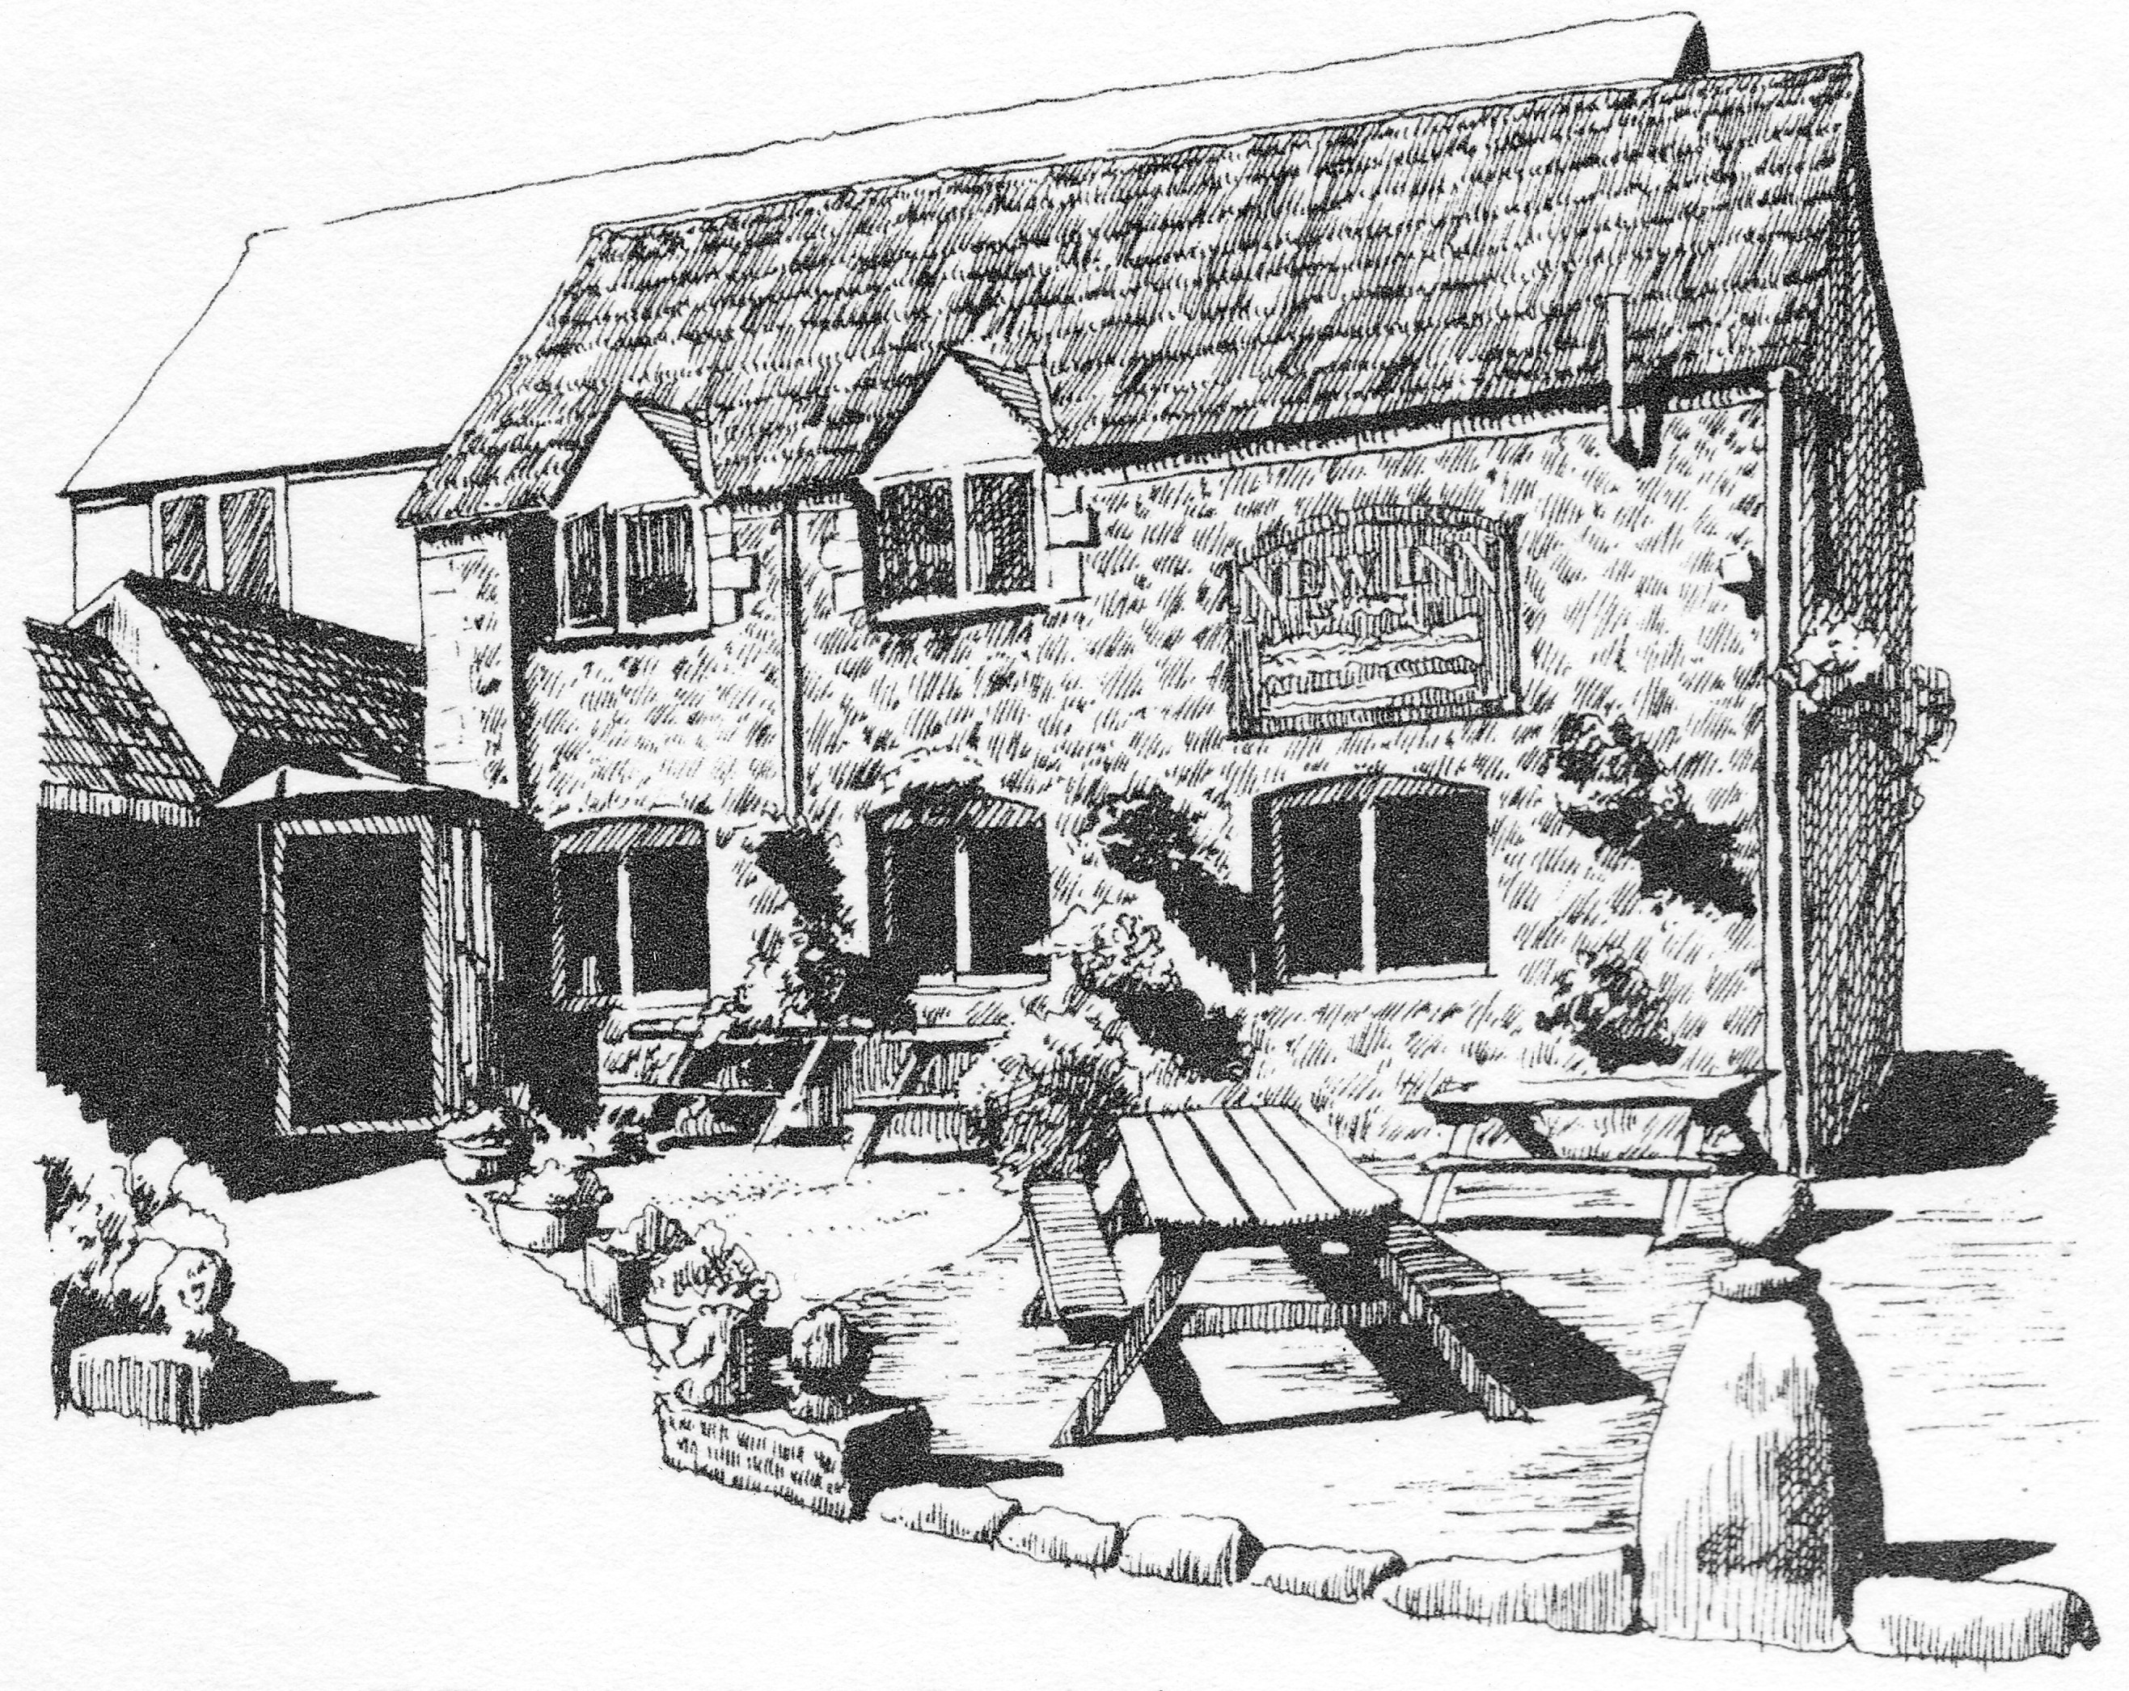

Dear [resident name],

Introduction
This share offer invitation is from the management group of the Halse and District Community Benefit Society, which has been formed with the vision of refurbishing the New Inn at Halse for the benefit of the community and to secure its future as a thriving community hub.
Share offer summary
Minimum target to be raised: £10,000
Maximum target to be raised: £100,000
Price per share: £1
Minimum share holding: £100
Maximum share holding: £50,000
Offer opens on 1st Dec 2020 and will stay open until 31st Dec 2021.

The story so far
The New Inn at Halse is an 18th century coaching inn, formerly known as The Kings Arms, The Butchers Arms and The Red Lion. It became the New Inn in 1789. The pub has been very successful in the past and following an extensive renovation in 2005 was a thriving pub, restaurant and B&B business. Business declined over the last 10 years and the pub found itself in danger of closing. It was purchased by the local community in September 2020 and has been partly refurbished by funds raised in our first share issue. A month after opening in Oct the pub closed (for all but takeaways) in response to COVID-19.
Over the last few months refurbishing work has continued and we have established the necessary business framework to ensure the saving of our local pub for the benefit of the community becomes a realistic proposition. Funding of £382,000 from the first share issue along with a £100,000 injection from the Plunkett Foundation has put the pub on the right trajectory for survival. This along with installation of a new management team saw the pub doubling the projected monthly income before the second Covid lockdown was imposed in Nov 2020. Despite this closedown, refurbishment continues along with improving the facilities and services on offer and the letting rooms are expected to become available again in early 2021 Covid permitting.
Additional changes need the funding which will see the pub offering the area a number of additional facilities such as a café by day and skittles alley by night, postal services, ready meals, a take-away service, and ultimately a bespoke carer service designed exclusively for the local area.
The Proposal
For most villages a pub is an important service; it is a meeting place, communication centre and an important lynchpin of village life. Much of the appeal of our village rests on its sense of community. It is the reason why many people have moved here and remain here. The presence of a community pub with a café and other services, would greatly enhance that community spirit and give Halse and district a stronger sense of place.
The Pub
The primary objective will be to establish a pub operation which meets the needs of the community. It must be a well run and profitable business. Feedback we have received through the initial investigation period which included a questionaire indicated that there is enthusiasm for a more extensive pub/café facilty. The pub would serve reasonably priced but wholesome ‘pub-grub’, in addition there would be more restaurant style ‘specials’ offered at peak times. We want to provide food and facilities that suit the whole family, young to elderly and attract visitors from outside the district as well as engaging the close population. Other activities such as themed nights, quizzes and live music remain popular among our locals, and although skittles have already returned, we envisage more skittles teams may make the New Inn their new home once covid restrictions permit.

A local café
The idea of a café was eagerly embraced in the questionnaire responses and is something the H&D CBS would like to take forward. Initially targeted at peak mornings for locals and cyclists, it would provide a much needed social opportunity for us all as well as catering to the growing cyclist, tourist, Home worker and walker communities.
B&B
The New Inn can provide five en-suite rooms for B&B and a sixth studio apartment. They will be reasonably priced in line with similar establishments locally and will provide a regular income throughout the year.
Aspirational future services
Other services that were popular in the questionnaire results were post office facilities and delivery collection. In addition, farm shop deliveries, art exhibitions and book exchange were some of the diverse range of services suggested by questionnaire respondents.
Business Plan
A business plan was drawn up and is now being used as a guideline for the way forward. In summary it concludes that the financial viability of the New Inn as a trading entity has been analysed by both financial experts as well as experienced landlords who know the trade inside out. Their collective view is that the New Inn is most certainly financially viable as a country pub trading entity. Modelling of profit and loss shows a steady increase in profit and a healthy cash balance throughout. This is most certainly borne out by our first months trading (before the second lockdown) where even without our B&B rooms we were able to double our turnover against modelled predictions.
A number of trading options over and above those currently offered will be introduced to ensure that turnover will surpass current levels. Many of these have community benefit at their heart. The extra income generated by these additional trading options will be used to cover additional staffing costs which are seen as needed to ensure the New Inn meets the demands and desires of its customer base.
The structural viability of the New Inn has also been professionally analysed and found in need of major repairs. The costs of these repair works have been identified and the professional view is that once this repair work has been undertaken then the New Inn as a building will be sound well into the future.
Raising the funds needed to purchase, repair, refurbish where necessary, and redecorate was very successful in our first share issue and we are now looking to build on this by issuing a second share issue. The aims of this are twofold, firstly to continue to raise funds for the ongoing refurbishment but secondly to offer a mechanism for individuals not already invested to become part of this amazing venture.

The Structure
The Halse and District Community Benefit Society Ltd or H&D CBS (registration no 8456) has been formed using the model rules developed by the Plunkett Foundation and registered with the Financial Conduct Authority (FCA). In its rules is embedded the principle that if the society has a surplus, this will be made available for distribution to other community or charitable projects.
The primary objective of the society is to run the New Inn for the benefit of the community, and in the longer term, when there is any surplus, to use this for the benefit of the wider community of Halse and its surrounding district.
The activities of the H&D CBS – primarily overseeing the business of the New Inn - will be managed by the Management Group. This will be made up of volunteers who have the appropriate expertise to fulfil the roles outlined below. An interim H&D CBS Management Group has been appointed from the Steering Group to serve until the first AGM. The first AGM must be held at the end of the first trading year 30th September 2021 and must be between 30th September 2021 and 31st March 2022.
At the first AGM, all members of the first Management Group will stand down and elections will be held for the next Management Group. Management Group elections will take place annually thereafter at the AGM. The initial management Group comprises of the below eight founder members:-

Chairman: Stephen Hoole
Vice Chair: Mike Davis
Treasurer: Heather Davis
Secretary: Mark Ellis
Media & Communications: Nick Eakhurst
Operations Director: John Wrelton
Fund Raising And Grants: Ian Walker
Property Improvement and Maintenance: Kate Payne

Anyone who buys the minimum number of shares becomes a member of the H&D CBS and can vote at the AGM and stand in Management Group elections.
In forming the H&D CBS we have taken care to ensure there is an Asset Lock on all of the assets the H&D CBS hold (essentially the pub). Although shares can be repurchased by the H&D CBS from investors should they wish to get back their investments, the building cannot be sold unless it is for the benefit of the community.

The Share Offer

This community share offer invites you to invest in the Halse and District Community Benefit Society Ltd (H&D CBS) so that we can continue to run the New Inn, renovate the building and support its future operations. The pub business will be operated by a management couple. The H&D CBS Management Group will oversee the operations and the finances of the business in conjunction with the management.
Each share is worth £1 and there is a minimum holding of £100 and a maximum of £50,000. Anyone who invests the minimum of £100 becomes a member of the Society and has a vote and therefore a say in the affairs of the business at General Meetings. The business operates strictly on a one member, one vote basis, regardless of how many shares you hold. Members must be 18 years old and over, although shares can be held in trust until a person becomes 18 years old.
The share offer will remain open to applications until 31st Dec 2021 as this will allow newcomers to the village to participate/support this community venture.
It is recommended that you seek independent financial advice before making an investment. However this should be regarded as a long-term social investment with modest financial returns and should be judged accordingly.
Returns on investment
To pay interest to shareholders, the interest rate for each year will be proposed by the Management Group and put to a vote at the Annual General Meeting. The proposal will be based on the performance of the society and will prioritise the need to maintain reserves and community benefit. It is our intention to pay interest of between 1% and 2% annually, however no interest on investments will be paid by the CBS until at least Sept 2023. Thereafter, interest may be paid annually to members at a rate set by the management group depending on performance of the pub and its surplus funding levels. It is each member’s responsibility to declare such earnings to HMRC if appropriate.
It is important to note that the value of the shares will not increase and the H&D CBS will not pay dividends. The only financial benefit for members is the interest paid at the discretion of the Management Group.
Withdrawing shares
You may be able to recoup your initial investment in the future by selling your shares back to the H&D CBS at the discretion of the Management Group. To give the business a chance to establish itself there will be an initial period of 3 years during which time the buying back of shares will be restricted (except in the case of death or bankruptcy), but thereafter the expectation is that there may be profits to fund withdrawals within parameters agreed by the members.
These shares are not transferable and cannot be sold. The only way to recover the value of the shares purchased is to give three months notice to the Management Group.
The Management Group reserves the right to refuse a withdrawal request if it would endanger the business.
In the event that the building and other assets of the New Inn are sold, for whatever reason, the shareholders would be repaid their investment from the proceeds of such sale, after repayment of any debts. Any surplus would have to be paid to a charitable or community body as determined by the Management Group.

Risks and Warnings
This is deemed to be a long-term social investment with modest financial returns. After several years when the pub has established a positive cash flow there will be limited opportunities to withdraw capital but the majority of shareholders will be expected to leave their investment with the pub for many years.

Restrictions on the withdrawal of your investment
The rules permit withdrawals after three years (earlier in the case of death or bankruptcy) but this is at the sole discretion of the Management Group. Thereafter, if a large number of members wanted to withdraw their shares in a particular year, then there may not be sufficient funds available. In which case the requests may be prioritised in the order in which they were received, and the full amount requested may not be available.
Loss of capital
As with any business, the New Inn of the future will be subject to risks such as the failure to achieve the predicted level of turnover, profit levels fail to cover costs and restrictive government legislation. This list is not exhaustive, and any trading activity is vulnerable to change or unanticipated risk. We have prepared a business plan and firmly believe that with your support the business will be profitable, provided that we ensure we are responding to what you, our community, needs. A separate sub-committee is already working on this plan and proposals to make sure that the business is a success.
The member’s liability for the business is limited to the value of their shares, therefore should the project fail, no further liability can fall on the shareholders.
No investment guarantees
This Share Offer is exempt from the Financial Services and Markets Act 2000 or subsidiary regulations; this means you have no right of complaint to an ombudsman. A community benefit society is registered with, but not authorised by, the Financial Conduct Authority and therefore the money you pay for your shares is not safeguarded by any depositor protection scheme or dispute resolution scheme. As the whole of your investment could carry a risk, please consider it carefully in the context of the complete share offer document and, if needed, seek independent advice.
Data Protection
The H&D CBS will use its best endeavours to safely store, use and process personal data only for the purposes for which it is gathered and not keep it longer than necessary. Personal data will be used solely for the purpose of maintaining a register of members and potential members as required by the rules of the society and for communicating with members. We will not share any members’ personal information with third parties.

Frequently asked questions

Q: Are joint applications allowed?
A: Yes. However you should note that only the first named investor on the application form will be a member of the H&D CBS with voting rights. If a couple would both like to be members, then each person should make a separate application.
Q: Can I invest on behalf of my children or grandchildren?
A: Yes, as long as they are over 16 years of age, you can buy shares on their behalf. As they will be the legal named shareholder in their own right, they need to consent to becoming a shareholder.
Q: What happens to my shares if I die?
A: Your shares will form part of your inheritance and can be transferred under the terms of your will. The rules allow a person to nominate a beneficiary who can receive the shares (up to £5000 and the society holds the nominations list); anything above that is dealt with via probate.
Q: What are the minimum and maximum investment amounts?
A: The minimum that you can invest is £100 (i.e. 100 shares at £1 each). The maximum has been set by the Management Group at £50,000.
Q: What happens if the funding target is reached?
A: If the total funding target is reached within the initial share offering time-scale we may still accept any further applications if it means we can reduce our borrowing. The scheme will also remain open for any newcomers to the village. Share capital will be allocated on a first come first served basis. Shares capped or reduced on over subscription?
Q: When will I start to receive interest payments?
After 3 years, if the Management Group considers the finances to be secure enough to do so. We aim to pay annual interest in the range of 1% to 2% annually.
Q: Can I sell my shares?
A: No. The legislation for community benefit societies is very clear that shares cannot be traded or transferred. The statutory asset lock is designed to ensure that any increase in share value is only used for community benefit.
Q: When can I withdraw my shares?
A: According to the Rules of the CBS shares cannot be withdrawn for at least three years (except in exceptional circumstances such as death or bankruptcy), and then only if the CBS has sufficient reserves to do so without jeopardising the business.
Q: Will my personal information be secure and kept confidential?
Personal data will be used solely for the purpose of maintaining a register of members and potential members as required by the rules of the CBS, and for communicating with members. We will not share any members personal information (names, addresses, phone numbers etc) with third parties.

What you need to do now
If you have already decided to support the Community Benefit Society by buying shares, please complete the form attached which is a formal application for a share holding. The form should be printed off and signed as indicated.
Making payment
The Community Benefit Society account details are:-
Account Name: Halse and District Community Benefit Society Ltd
Bank Name Metro Bank
Sort code: 23-05-80
A/c: 39504601

We would prefer you to transfer monies by BACS if possible. Otherwise, please make cheques payable to:- Halse and District Community Benefit Society Ltd and send to our treasurer:
Heather Davis
Manor Farm
Halse
TA4 3AB

Share certificates will be issued once your funding is received along with your details on the form below. We anticipate that you will receive your certificate within 3 weeks of this.
We appreciate that many of you will want your pledges to be kept confidential and so only one member of the steering group will open the envelopes and will provide the rest of the group with the totals only.
If you have any questions about the formation of the Halse and District Community Benefit Society or the proposed share structure then please feel free to speak to: Stephen Hoole (Chairman), Old Cider House 01823431773 or Mike Davis (Vice Chairman), Manor Farm 07846956036

Yours sincerely,

NAME Stephen Hoole NAME Mark Ellis
Title Chair of Management Committee Secretary of Management Committee
APPLICATION FOR SHARES IN SECOND SHARE ISSUE

- Each share costs £1. Minimum investment is £100.
- You can buy in batches of £100s
- Shareholders must be 18 years and over
- By investing you are applying for membership of the Halse and District Community Benefit Society

Payment

To invest by bank transfer or cheque, complete and return this form to:-

The secretary, Halse and District Community Benefit Society Ltd
C/O 9 Halse Manor, Halse, Taunton, Somerset, TA4 3AE

Or Scan and Email to halsecommunitypub@gmail.com

Bank Metro Bank
Account Name: Halse and District Community Benefit Society Ltd
Sort code: 23-05-80
A/c: 39504601
Reference Your Name

Acceptance will be notified by email or post.

Contact Details

Full name (inc. Middle name):…………………………………………………………………………………………………………….
Address:………………………………………………………………………………………………………………………………………………
………………………………………………………………………………Postcode:…………………………………………………………….
Date of Birth:……………………………………Email:………………………………………………………………………………………..
Telephone:…………………………………………………………….Mobile:………………………………………………………………..
I agree to the conditions as set out in the share offer:
Signed………………………………………………………………………..Date:……………………………………………………………….
I, as signed above, wish to buy shares to the value of:…£……………………………….
I have paid by BANK TRANSFER / I enclose a CHEQUE (please make payable to ‘Halse and District Community Benefit Society’)
Your personal data will be held for the purposes of maintaining a register of members and potential members (as required by the rules of the CBS) and for communicating with members.

